# Introduction

* 1. **Interface Documentation Guidelines**

We have adopted specific interface documentation guidelines and conventions in order to make communication more uniform among the development team. First, all classes are named with singular nouns or noun phrases, with each word beginning with a non-capital letter. All objects derived from these classes (all class instances) will be named with a similar convention,. Methods are named with verb phrases; fields and parameters are named with noun phrases. Error status is returned via console.log(err) which directly prints them in to the console ,usually in the form of a non-Boolean status variable. Each class prototype will be included at the top of the header file before implementation of that class, and each class’ full interface will be desinged and changed in further development. Furthermore, each appropriate class will have fully pre-condition, post-condition, and invariant information, , including all attributes and methods.

# Packages

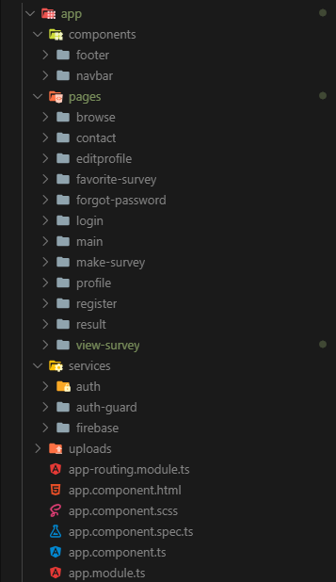The file organization of the code can be seen in the left.Our packages divided into 4 main parts and there are a lot of subsystem under each one of them.

These are as follows;

* Components Package: This package contains the main UI components , that is always visible.
* Footer: This represents the user interface that will be shown at the bottom on all other UI’s
* Navbar: This represents the user interface that will be shown at the top on all other UI’s.
* Pages Package: This package contains all of the UI’s used in Survey4All with all of the backend operations and functionality.

-Browse: This package represents the browse page, which means a whole page with UI and functions for browsing all of the surveys on the database.

-Contact: This package represents the contact page, which means a whole page with UI and functions for sending a message to Survey4all admins.

-EditProfile: This package represents the profile edit page, which means a whole page with UI and functions for editing their profile info like profile pic,phone etc.

-Favorite-Survey: This package represents the Favorite Surveys page, which means a whole page with UI and functions for the user to let user see and track their favorited surveys.

-ForgotPassword: This package represents the Forgot page, which means a whole page with UI and function for users who forgotted their passwords and want a reset link o their email address.

-Login: This package represents the login page, which means a whole page with which connected to auth-service,for users to log in if they wwant to use survey4all more efficiently(ex: creating a survey requires to login)

-Main: This package represents the Main page, which means the first page a user is going to see, a landing page.

-MakeSurvey: This package represents the Create Survey page, which means a whole page with UI and functions for creating a new survey by a user to share.

-Profile: This package represents the Profile page, which means a whole page with UI for users information stored and can be seen by the user.

-Register: This package represents the register page, which means a whole page with UI connected to auth service for auth operations. This page is a regular registeration form page.

-Result: This package represents the results page, which means a whole page with UI and functions for examining the result of a survey, visualized with the data.

-ViewSurvey: This package represents the Default Survey page, which means a whole page with UI and functions for a survey to be solved or completed by any user.

* Services Package: This package contains the required servies run by the system which includes connection to database , most of the auth operations and CRUD operations.

-Auth Service: This package represents the auth operations. It controls the operations like login, register,resetpassword,logout and it provides the user info to all pages in the system like user is logged in or not , what is the name of the user etc.

-AuthGuard Service: This package controls the limitations of the users , non users and admin. It protects the pages that should not be seen by everyone for example, creating a survey requires a user to be logged in so authguard will redirect user to the main page if the user somehow manage to find the orute fort he make survey page.

-Firebase Service : This service represents the main CRUD operations base. Firebase Service is getting data from the database and sends it to required pages. Reading Creating ,Updating or deleting operations moslty controlled here.

* Uploads:This package handles the uploading process on multimedia side. If a user wants to change their profile pic this service will be used.